Contents

[Buffers 2](#_Toc512345415)

[PTx.2% (1L) 2](#_Toc512345416)

[PTwH (1L) 2](#_Toc512345417)

[Permeabilizing buffer (50mL) 2](#_Toc512345418)

[Secondary antibodies 2](#_Toc512345419)

[Sample Collection 2](#_Toc512345420)

[Embed brain 3](#_Toc512345421)

[Immunolabeling 4](#_Toc512345422)

[Clearing tissue 5](#_Toc512345423)

[Tissue check 5](#_Toc512345424)

[Troubleshooting 5](#_Toc512345425)

[Antibodies tested 6](#_Toc512345426)

[Primaries: 6](#_Toc512345427)

[Secondaries: 6](#_Toc512345428)

[Light Sheet Imaging 6](#_Toc512345429)

[Mount to sample holder 6](#_Toc512345430)

[Schedule LaVision Ultramicroscope at Microscopy Core with Nikos & Sijie 6](#_Toc512345431)

[Quantification 6](#_Toc512345432)

[References 7](#_Toc512345433)

**eDISCO**: **E**thyl cinnamate based three-**d**imensional **i**maging of **s**olvent-**c**leared **o**rgans: without and with immunolabeling

|  |  |
| --- | --- |
| Tissue | Estimated completion time  (sack to image) |
| hemisphere brain (eDISCO) | 27 days |
| Whole brain (eDISCO) | 33 |

E:\_GDRIVElocal\_BIGcode\_myClearing\18_04_19_TH-a647\15-56-31_1-3x_1.tifE:\_GDRIVElocal\_BIGcode\_myClearing\18_04_13_TH-LC_12x\12x_sag_TH_ghost_zoom1.tif

# Buffers

### PTx.2% (1L)

* 100mL PBS 10X (900mL H2O)
* 2mL Tween20 (iDISCO uses tritonX)

### PTwH (1L)

* 100mL PBS 10X
* 2mL Tween-20
* **1mL of 10mg/mL Heparin stock solution**

### Permeabilizing buffer+sap (Perm+sap, 50mL)

* 42mL PTx.2%
* 3mL of Goat Serum
* **5mL of DMSO**
* **0.02% Sodium azide (0.01 g to 50mL, or 0.1g to 500mL)**
* **raise to 1% Tween20 (add 0.4mL)**
* **0.1% saponin (from 5x stock, so 10 mLs of 5x per 40 mL perm buffer**

# Secondary antibodies

Do not use chemical dyes, use ALEXA dyes or fluorescent proteins only (communication with Klingberg)

# Sample Collection

1. Anesthetize the mouse.
2. Perfuse with 10mL PBS.
3. Perfuse with 10mL 4%PFA/PBS.
4. Dissect the brain/organ and trim to the appropriate size.
5. **REMOVE meninges**
   1. Place brain in petri dish ventral side up.
   2. Identify vascularture/circle of willis. From medial to lateral, peel meninges (pia and arachnoid mater) from the surface of the brain.
   3. Pay special attention to the ventral aspect of the brain, as this is a source of antibody absorption prior to clearing.
6. Fix in 1xPBS/4%PFA at 4°C, 2 days with rocking.
7. Wash in PBS on rock: RT 1 hr x 3times.

# Embed brain (only for small sections)

1. make 1% agarose in distilled H2O (0.25g 25mL H2O for two brains)
2. Embed brain in 1% agarose.
3. Trim agarose to make a cube (~2mm extending from each surface).
4. Make desired cut (e.g. sagittal midline).
5. Place on opposing sagittal face to ensure flat imaging surface
6. Wash in PBS on rock

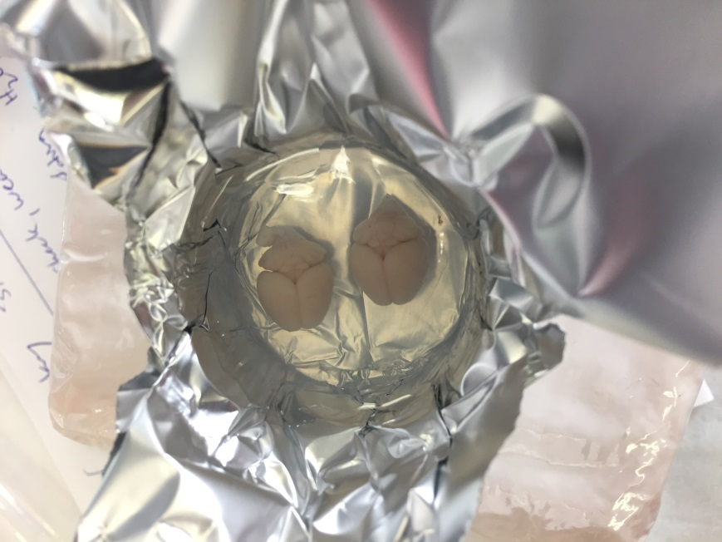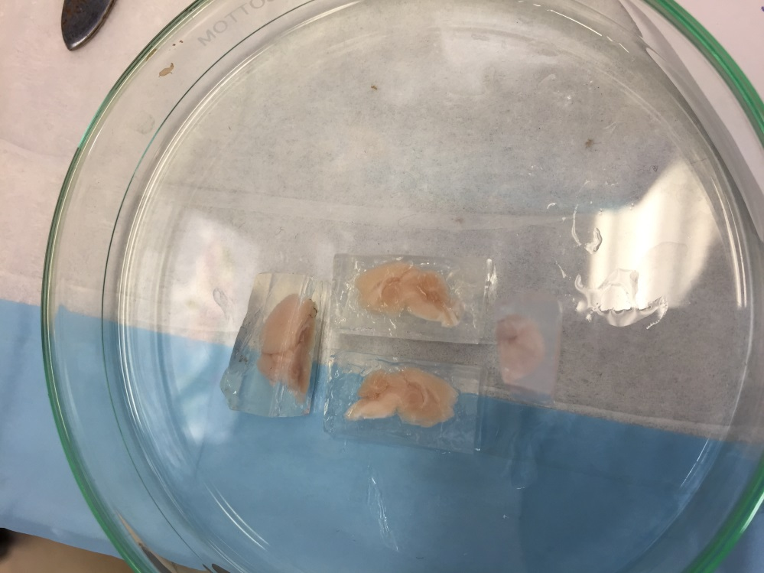

# Immunolabeling

After fixation, wash and embedding:

|  |  |  |  |  |  |  |  |
| --- | --- | --- | --- | --- | --- | --- | --- |
| Tissue | Bleach 6% H2O2 in PBS1 | Perm+sap buffer | 1° antibody, in Perm+sap buffer | Wash sample | 2nd antibody, in Perm+sap Buffer3 | Wash sample | Subtotal |
| hemisphere brain (eDISCO)1 | O/N rock, then wash next day PTx.2% @ RT for 10 min | 4 days rock @ 37°C2 | 14 days on rock @ 37°C | wash PTwH 5x 1hr each on rock @ 37°C (ok to leave O/N) | 7 days on rock @ 37°C | wash PTwH 5x 1hr each on rock @ 37°C then at least 2 days in fresh PTwH on rock @ 37°C | 20 |
| whole brain (eDISCO)1 | same | same | 10 days | same | 10 days | same | 26 |

1. For each vial, make to 6 mL total volume.
2. To heat @ 37°C, use electric blanket (until we can afford an incubator).
3. For secondary antibody, spin down vial for ~5 sec to avoid precipitates. Then pass your final mix through 0.22 µm filter.

Nutating rocker (<https://www.fishersci.com/shop/products/nutating-mixer-fixed-speed120v/88861041>):

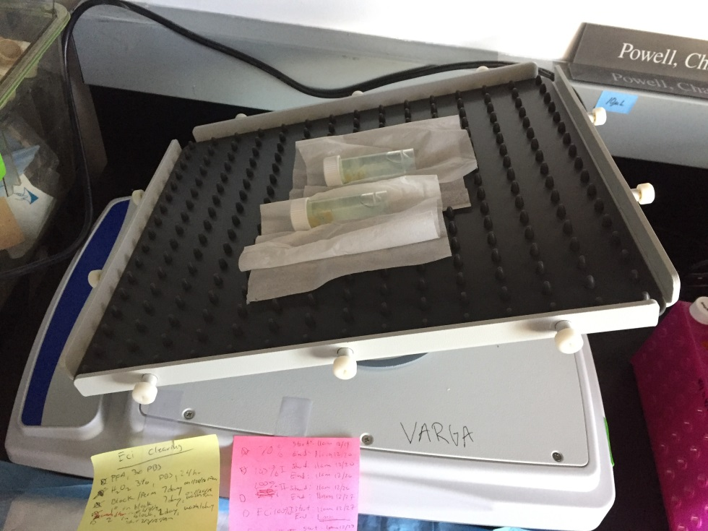

From Blocking step on, use light shield/thermal electric blanket and thermometer.

# Clearing tissue

After immunolableing:

|  |  |  |  |  |  |  |
| --- | --- | --- | --- | --- | --- | --- |
| Tissue | 40% EtOH + 2% Tween (pH 9) in H2O | 60% EtOH + 2% Tween (pH 9) in H2O | 80% EtOH + 2% Tween (pH 9) in H2O | 100% EtOH + 2% Tween (not pH adjusted) | 2x 100% ECi | subtotal |
| hemisphere brain (eDISCO) | 1hr then change to fresh for RT on rock O/N | 1hr then change to fresh for RT on rock O/N | 1hr then change to fresh for RT on rock O/N | 2 days, add fresh EtOH b/w days @ RT | 4hr then change to fresh O/N @ RT | 7 days |
| whole Brain (eDISCO) | same | same | same | same | same | 7 days |

Eg. Make 6mL/vial 🡪 9.6mL EtOH + 2.4mL Tween

# Tissue check

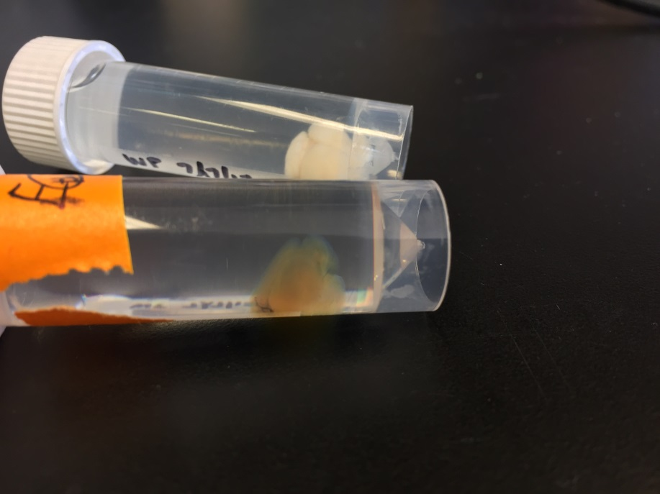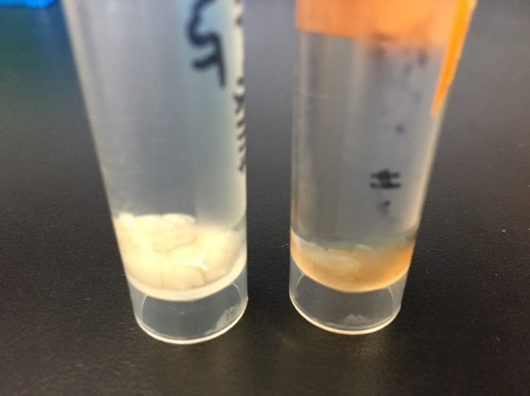

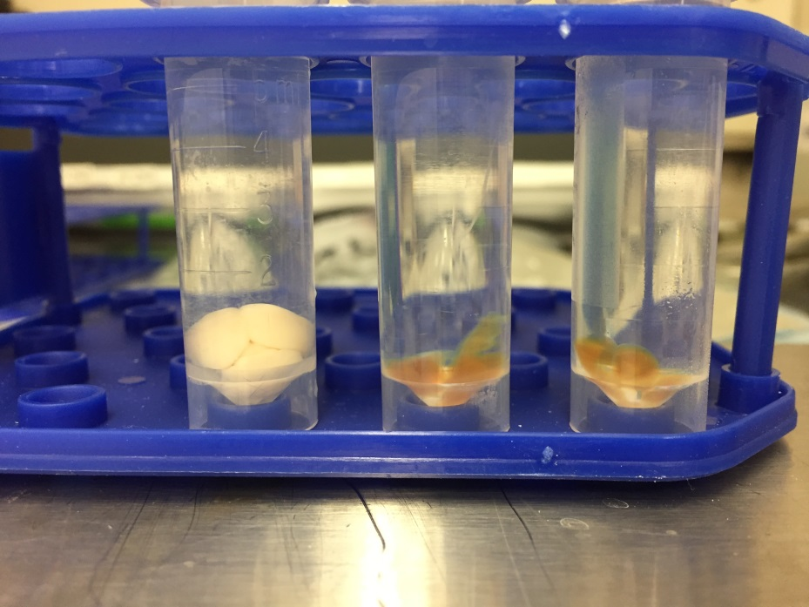

# Troubleshooting

**There is a strong surface background / ring-like background staining.**  
This seems to happen because the primary antibody is too concentrated. Reduce the concentration.

**The samples have an amber color.**  
If the coloring is light, this is normal and will not prevent the imaging. If the amber color is too pronounced, the sample was kept for too long in THF, or it got oxidised because too much air was present in the tube.

# Antibodies tested

## Primaries:

* Tyrosine hydroxylase: 1:100 in 6 mL vial 🡪 60 uL/vial
* Norepinephrine transporter: ???
* dopamine β-hydroxylase: ???
* cFos: ???
* SMA: ???
* AT8-human p-tau 🡪 (attempt after successful TH)

## Secondaries:

* Secondary Gt Anti-Rb AlexaFluor 647 (A-21245): 1:100 in 6 mL vial 🡪 60 uL/vial

# Light Sheet Imaging

### Mount to sample holder

Use Krazy glue, not locate cyanoacrylate (ECi dissolves this)

### Schedule LaVision Ultramicroscope at Microscopy Core with Nikos & Sijie

(Korey has the account)

* Verify with 1.3x whole sample
* Then max at 4x once verified

# Quantification

* Learn clearmap (but I’ll most likely need access to the Microscopy Core’s server to run a python script on it):
* <https://rawgit.com/ChristophKirst/ClearMap/master/docs/_build/html/index.html>
* Test on trial dataset first (Reneir’s cFos mouse brain).
* IMARIS

# References

* Klingberg et al., Fully Automated Evaluation of Total Glomerular Number and Capillary Tuft Size in Nephritic Kidneys Using Lightsheet Microscopy, 2017.
* Renier et al., Mapping of Brain Activity by Automated Volume Analysis of Immediate Early Genes, 2016.
* Renier et al., iDISCO: a simple, rapid method to immunolabel large tissue samples for volume imaging, 2014.
* <https://idiscodotinfo.files.wordpress.com/2015/04/whole-mount-staining-bench-protocol-methanol-dec-2016.pdf>
* <https://transparent-human-embryo.com/?page_id=634>
* <https://www.nature.com/protocolexchange/protocols/3389#/procedure>